Erol et al., 2015

Existing analytical solutions for thermal analysis of ground source heat pump (GSHP) systems evaluate temperature change in the carrier-fluid and the surrounding ground in the production period of a single borehole heat exchanger (BHE) only if a continuous heat load is assigned.

Here: authors modified the Green's function, which is the solution of heat conduction/ advection/dispersion equation in porous media, for discontinuous heat extraction by analytically convoluting rectangular function or pulses in time domain both for single and multi-BHEs field. + verified with numerical FEM (COMSOL Multiphysics ) to model 30 years production period + recovery period of 30 years- > good agreement of results both for conduction and advection dominated heat transfer systems, with shorter computational time for analytical solutions

They investigated the **sustainability and recovery aspects of GSHP systems** by using proposed analytical models **under different hydro-geological conditions**. - linear relationship between thermal conductivity of the ground and the sustainable heat extraction rate is demonstrated for multi-BHEs.

**Numerical models:**

Rybach and Eugster [3] carried out 2D numerical studies on the sustainability and renewability aspects of a single BHE in a long term performance in Switzerland 🡪 load profile of heat extraction based on 11 years dataset + extrapolation of 19 based on meteo data.

* Show temperature decrease in the ground at different distances away from BH during the production period of 30 years and subsequent 30 years as the recovery phase 🡪 temperature change of the ground > ~7 K at the distance of 0.3 m + heat recovery in several years when the operation is stopped, and after the 30 years recovery phase, temperature drop about 0.1 K regarding to undisturbed ground temperature.

Signorelli [4] investigated the sustainability of BHEs with 3D numerical studies for both a single and multi-BHEs 🡪 temperature change at 50 m depth and 0.1 m distance from the BHE < 0.1 K after a 70 years recovery period for multi-BHE field vs 24 years for a single BHE + investigated far field behaviour of BHE for different operation periods: operation hours subdivided to months out of the total 1800 h operation time per year: i.e.:

* + single load profile: 60h/month production (300 kWh extracted per month, 9000 for 1 year) + rest of month is recovery – represent 5000 W (50 W/m for a 100m long BH)
  + multiple load profile: 2h operation per day + 22h recovery
  + 300 kWh extracted over the whole month (i.e. ~4.16 W/m continuous heat extraction).
* Similar temperature change in the ground after a one year operation (±0.1 K at 0.1 m distance from the BHE). Therefore, here a constant continuous heat extraction of 10.27 W/m set in analytical solution for a 30 year simulation scenario (total extracted energy = 9000 kWh per year = 50 W/m x 100m x 1800h distributed hourly for single BHE)

Lazzari et al. [8] studied long-term performance of single and multi-BHEs field with periodic (sinusoidal) heat load only in a conduction dominated heat transfer system under the consideration of two different ground thermal conductivity.

Zanchini et al. [9]. showed that with increasing of Peclet number (proportional to the groundwater flow), the performance of BHEs field becomes more sustainable.

“In long-term operation of BHE, the sustainable heat extraction and the ground temperature recover after the operation depend on hydro-geological and thermo-physical characteristics of the ground.”

**Analytical solutions available** (to avoid high computational demand of numerical models in 3D when discontinuous operation is taken into account, but most of them considered constant continuous extraction/injection in tie for single BHE):

* Eskilson [10]: simple analytical solution for discontinuous heat extraction, neglect 3D effects and only provide sinusoidal oscillations of temperature signal depending on the assigned distance apart from a single source.
* Claesson and Eskilson [17] presented 1D analytical solution of a finite line heat source to analyze dimensionless temperature change of subsurface for single pulse, and pulsated heat extractionrate. T

Here: objective is to obtain an analytical solution to evaluate temperature change in the ground both for single and multi-BHEs that considers discontinuous heat extraction, thermal conduction, advection and dispersion 🡪 Green's function modified to account for axial effects and GW flow 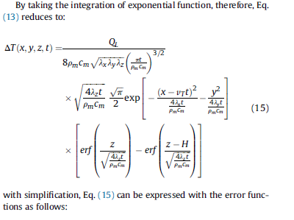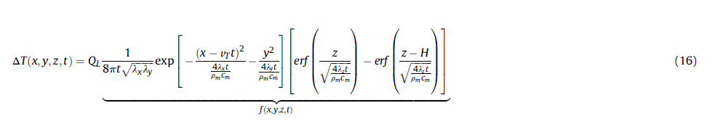 + convolution of that analytical function with a rectangular function or pulses which have different period lengths and pulse heights, to apply a discontinuous injection or extraction of heat in time domain. (x, y, z, t) function is convoluted with a rectangular heat extraction function qL(t)





* The evolution of the mean fluid temperature of the carrying fluid to maintain a constant heat extraction rate is evaluated along the time.
* Temperature distribution in the surrounding ground deduced in 3D.
* Sustainability/recovery aspect studies using MATLAB based on verified analytical solution + analyse impact of production period on the ground temperature 🡪 comparison ground temperature over time at 25 m depth for numerical/analytical approach w/ or without GW.

Results:

Single BHE: first heat extraction phase generates larger temperature decrease in the point located in the x-direction when groundwater flow and dispersion are considered. Recovery phase accelerated due to water flow + subsequent heat extraction induces lower temperature change in the ground close to the BHE. With time, temperature is impacted at larger distance in the direction of the water flow when the groundwater flow and the dispersion are considered.

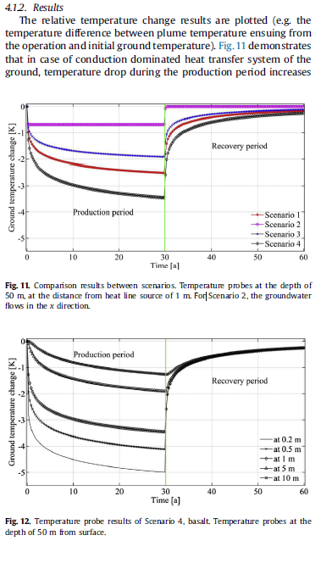 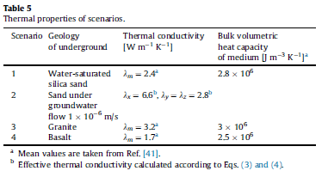

In case of conduction dominated system, temperature drop during the production period increases as conductivity decreases, but after recovery period, temperature change of those scenarios is not significant. GW flow and dispersion can provide more sustainable performances and quick recovery of ground. 🡪 in case with low thermal conductivity, mean temperature decrease away from the BHE (almost 10m) is still 0.5K after recovery period.

Notes:

* thermal dispersion is a linear function of groundwater flow and relates to the anisotropy of the velocity field [31,35]. Depends on porous media = Darcy's velocity, particle size of the media, field scale). See Ref 36-38 for empirical relationships
* shows temperature variation around the line sources in the 3D model + axial effects seen close to the beginning and at the end of borehole length but heat fluxes distribution / source of the recovery not analysed (see XXX)
* analysis of the recovery period